Name:____________________________ Date:______________

An American Tail

[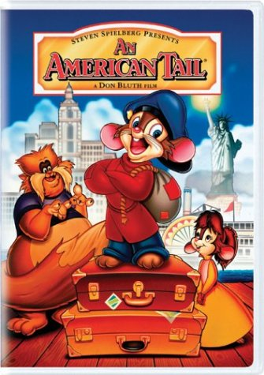](http://www.amazon.com/gp/associates/link-types/marketplace.html?t=teachwithmovieso&asin=B0000VV4W2)

1. What is the last name of the mouse family?
2. In what way do they feel America is like a fairy tale?
3. What were conditions like on the boat?
4. Where do the immigrants land in New York? (What is the name of the immigration station?)
5. As the immigrants are being “processed”, what does the official sometimes change?
6. What is under construction on the island where Fievel lands?
7. Describe the conditions in the New York City streets that Fievel wanders.
8. Who are the Mott Street Maulers? What do they represent in the “human world”?
9. Why doesn’t the Statue of Liberty look green?
10. What do you think the cats in the movie actually represented?
11. What were your thoughts of the movie? Do you think that it did a good job of representing immigrants coming to the United States?