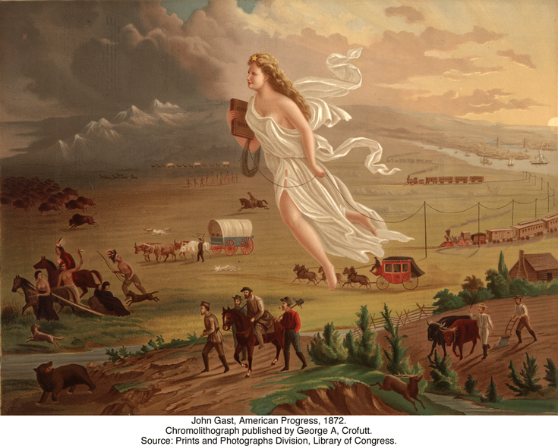
American Progress
by John Gast, 1872 b J

POSTER #1
- Who does this woman represent? _____________________________________________________________
- What direction is she going? (compass direction) __________________________

- What is she carrying in her right and left hands? _____________________________________________________________

POSTER #2
- Who or what are the people and animals looking at? _____________________________________________________________

- From the expressions/body language of the people and animals, what emotion are they feeling? _____________________________________________________________
- How are they being threatened? In other words, what is happening to their way of life? _____________________________________________________________

POSTER #3
- In which direction are the people moving in all of these images? _______________________________________________________________

- In areas where settlers have already arrived, how are they using the land? _______________________________________________________________

- Study the image with the four men. Are they bringing possessions in a covered wagon? What are they looking for? Why would they leave so unprepared? ______________________________________________________________________________________________________________________________

POSTER #4
- Starting from the east, how is the sky changing? _______________________________________________________________

- Where is the sun? Is it rising or setting? _______________________________________________________________
- What message is implied by these images? ______________________________________________________________________________________________________________________________

