Name: __________________________ Due Date: _______ Period: _______

4th Six Weeks CBA Review

What was the importance of the Louisiana Purchase to the United States?
Increased the size of the United States and continued the idea of Manifest Destiny.

What was the purpose of the Lewis and Clark Expedition?
To explore and new territory and find a waterway to the Pacific Ocean.

List 4 reasons people moved to the west?
More job opportunities, land was cheaper, hope to find gold in California, practice their religion freely.

Explain what is meant by the term “Manifest Destiny”
The belief that the United States had the right to expand from “sea to sea” from the Atlantic to the Pacific Ocean.

War of 1812
Causes  1. Impressment – kidnapping of sailor and making them fight for France or England  2. England and France would capture American trading ships and take the supplies/money.  3. Britain was giving weapons to Native Americans to help them fight the Americans as they expanded westward | Effects  1. Andrew Jackson becomes a national hero at the Battle of New Orleans and a sense of Nationalism (pride in your nation)  2. Increase in U.S. manufacturing…they had to make their own goods since they couldn’t trade during the war  3. Treaty of Ghent was signed…but it made no changes

Explain the history of “The Star-Spangled Banner”
Francis Scott Key’s description of the Bombing of Fort McHenry. Key witnessed the bombing from a British ship and wrote about what he saw during the night and at dawn the next morning.

What is the title of this painting and what does it represent?

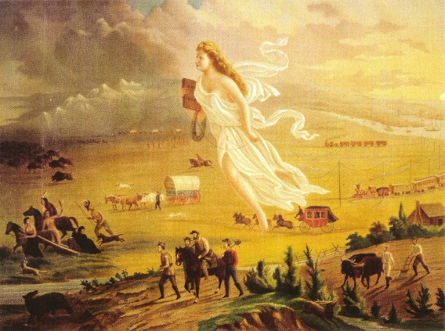
American Progress, it represents Manifest Destiny and the westward growth of the nation. You can go into a lot more detail here if you wish since you have done the American Progress activity with your students already.

Explain the economies (how people made a living) of the different regions
North | West | South
Industrial economy with factories that made goods (manufacturing). North needed cheap cotton from the South | Mining and food production | Plantations, cash crop (King Cotton), slavery

Trail of Tears
Causes | Description of Event | Effects
Gold found on Cherokee land in Georgia. | Cherokee and other tribes are forced from their homes and made to walk to Indian Territory (Oklahoma) and live on reservations (West of the Mississippi River) | ¼ of all the Cherokee die along the march. Native Americans lose their homeland and their way of life.

Industrial Revolution
Invention | Inventor | Effect
Cotton Gin | Eli Whitney | Made it faster to clean cotton, cotton becomes THE main cash crop, South makes money and slavery expands.
Steamboat | Robert Fulton | Made it faster and cheaper to ship goods between the North and South.
Telegraph | Samuel Morse | Made it much faster to communicate from state to state and across the country.
Interchangeable Parts | Eli Whitney | Goods can be produced in large quantities very quickly by low skilled workers (Mass production) Cities grow because move to them for work. Goods become cheaper.

Create a Map by drawing and labeling the following landforms and physical features on the blank map.
- Appalachian Mountains
- Great Plains
- Rocky Mountains
- Mississippi River
- Sierra Nevada Mountains
- Gulf of Mexico
- New Orleans
- Atlantic Ocean
- Pacific Ocean

