Name: __________________________ Due Date: _______ Period: _______

4th Six Weeks CBA Review

- What did the Louisiana Purchase do for the United States?

- What were the 3 goals of the Lewis and Clark Expedition?
1.

2.

3.

- List 4 reasons people moved to the west?
1.

2.

3.

4.

- Explain what is meant by the term “Manifest Destiny”

- War of 1812
Causes  1.  2.  3. | Effects  1.  2.  3.

- Who wrote “The Star-Spangled Banner”? _________________________________________

- Explain what inspired the poem that was turned into our national anthem:
__________________________________________________________________________________________________________________________________________________________________________________________________________________________________________________________________

- What is the title of this painting and what does it represent? _________________________________________________________________________________________________________________________________________________________________________________________________________________________________

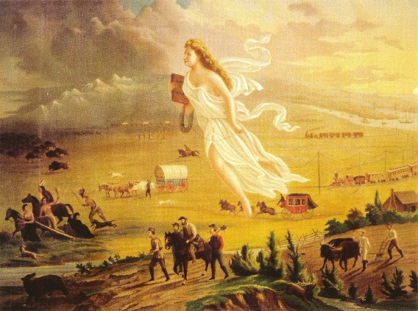

- Explain the economies (how people made a living) of the different regions
North | West | South

- Trail of Tears
Causes | Description of Event | Effects

- Industrial Revolution
Invention | Inventor | Effect
Cotton Gin
Steamboat
Telegraph
Interchangeable Parts

Steel Tipped Plow

- Create a Map by drawing and labeling the following landforms and physical features on the blank map.
- Appalachian Mountains
- Great Plains
- Rocky Mountains
- Mississippi River
- Sierra Nevada Mountains
- Gulf of Mexico
- New Orleans
- Atlantic Ocean
- Pacific Ocean
