Name: ___________________________________________ Date: _________________

1st Six Weeks CBA Review

What was the Columbian Exchange?

Describe three reasons why the Europeans explored and came to the New World.

Using the map, draw and label each leg of the Triangular Trade Route, listing the types of goods that were exchanged.
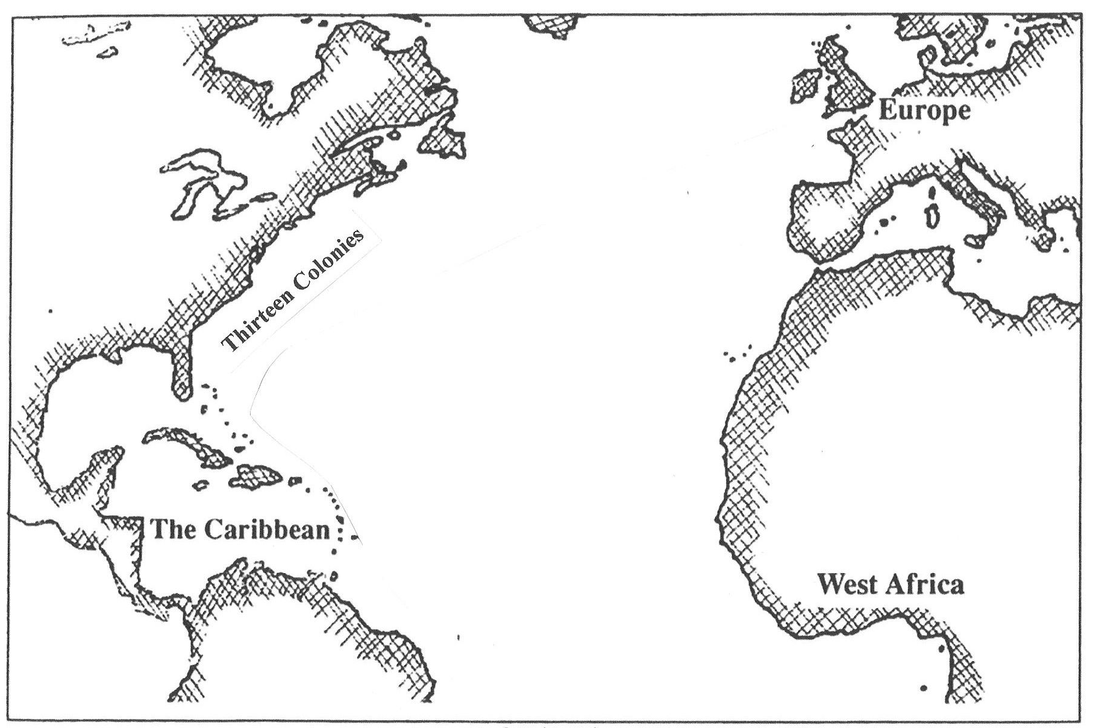
What is significant about 1565?

List the significant accomplishments of the following individuals.
William Bradford
William Penn
Anne Hutchinson
Roger Williams
John Smith

Describe the following types of government:
- Representative –
- Monarchy –
What factors contributed to the development of the free enterprise system in the original colonies?

Compare and Contrast the Mayflower Compact and House of Burgesses
Mayflower Compact | Both | House of Burgesses
- form of representative governments
- no women could vote
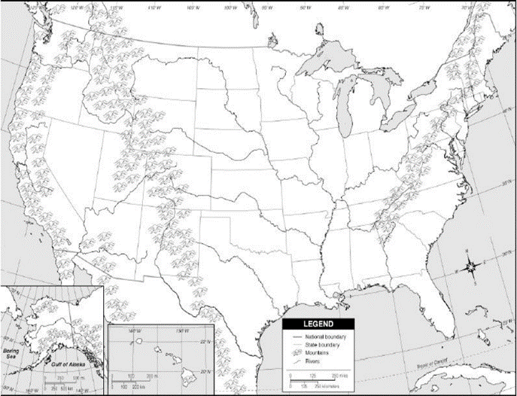
List the following physical features on the map provided.
- Appalachian Mountains
- Mississippi River
- Compass Rose
- Legend
- Scale

Colonial Region | Colonies in the region | Economy & Industry | Geography
New England Colonies | - Maine (Part of Massachusetts)  - New Hampshire  - Massachusetts  - Connecticut  - Rhode Island
Middle Colonies | - New York  - Pennsylvania  - New Jersey  - Delaware
Southern Colonies | - Maryland  - Virginia  - North Carolina  -South Carolina  - Georgia

